prepare a prototype (flow + structure) for a Document Management System (DMS) based on your detailed workflow (Creator → Approver → Issuer → Controlled Access).
-System Flow Chart (process steps)
-Module-wise Functionality (dashboard, upload, approval, issuance, access control)
-Database Design (sample schema)
-User Role Permissions
-Technology suggestion for development
Creator Login

Fill Doc Info (a–g fields)
Upload Word Doc (No header/footer)

Send to Approver (Notify)

Approver reviews doc (with header/footer)

Approve Document Decline (add remark)
Add remarks, Goes back to Creator
select sharing dept.

Send to Issuer (MR)
Issuer reviews doc (header/footer)

Issue Final Copy Decline (add remark)
Add Issue remark Goes back to Creator

Convert to PDF (Final)
Auto Notify All Users
Assign Control Copy Nos
Users View/Print Controlled PDF only
(No download, traceable by User ID)
--------------------------------------------------------------------------------
Responsibility: Module-Wise Functional Prototype Plan
Role | Features
Creator | Create new document entry, upload Word doc, view pending/returned docs, resubmit
Approver | View pending approvals, open doc (auto header/footer), approve/reject, add remarks, assign departments
Issuer (MR) | View approved docs, issue/reject, add final remark, track issued documents
User/Recipient | View issued documents (PDF only), print with control footer
Admin | Manage users, roles, departments, track logs, export reports

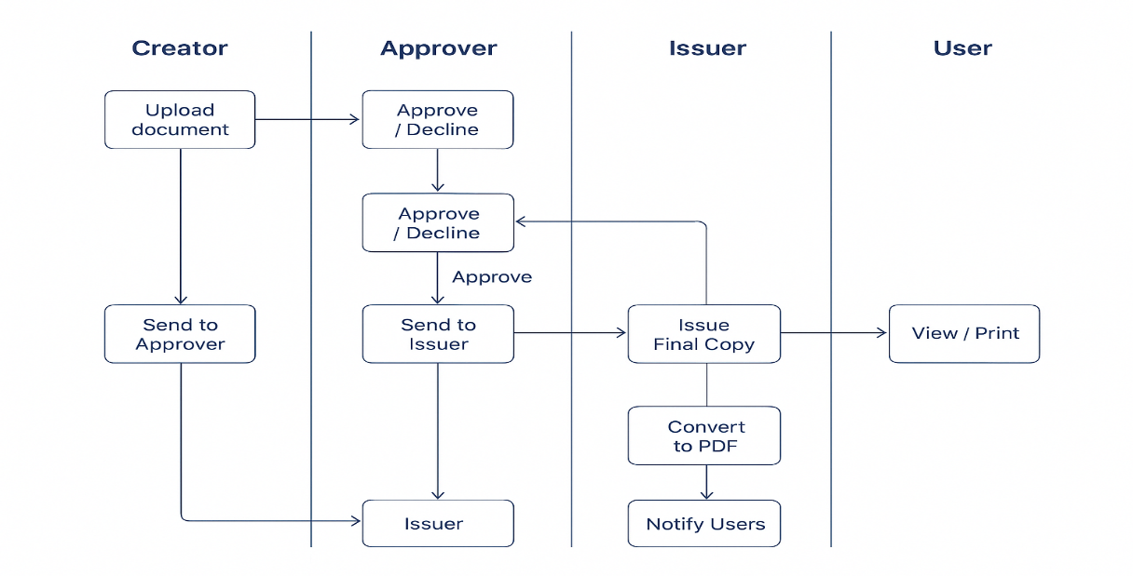
There is some conditions:
-Auto reminders for revision (based on due period)
-Comparison tool (old vs. revised doc)
-Version history tracking
-Export to Excel logs (per user or document)
-QR code footer for authenticity
-----------------------------------------
About Database table need:
users
Column | Type | Description
user_id | INT (PK) | Unique user
name | VARCHAR | User name
role | ENUM('Creator','Approver','Issuer','User','Admin') | Role
department | VARCHAR | Dept name
email | VARCHAR | Notification use

documents  Column | Type | Description
doc_id | INT (PK) | Unique document
doc_name | VARCHAR | SOP/Format name
doc_number | VARCHAR | Unique doc code
date_of_issue | DATE | Issue date
revision_no | INT | Revision count
due_period_years | INT | Review reminder
prepared_by | INT (FK) | Creator ID
reason_revision | TEXT | Revision reason
file_path | VARCHAR | Uploaded file
status | ENUM('Pending','Approved','Declined','Issued') | Current status
approver_id | INT (FK) | Assigned approver
issuer_id | INT (FK) | Assigned issuer

document_log
Column | Type | Description
log_id | INT (PK) | Log entry
doc_id | INT (FK) | Related document
user_id | INT (FK) | Who performed action
action | VARCHAR | Created, Approved, Declined, Issued
remarks | TEXT | Action remarks
date_time | DATETIME | Timestamp

document_access  Column | Type | Description
doc_id | INT (FK) | Document
user_id | INT (FK) | Recipient
control_copy_no | VARCHAR | Auto serial copy no.
view_access | BOOLEAN | Can view PDF
print_access | BOOLEAN | Can print PDF
print_date | DATETIME | Track printed date

Feature | Creator | Approver | Issuer | Recipient | Admin
Create Doc | ✅ | ❌ | ❌ | ❌ | ✅
Approve Doc | ❌ | ✅ | ❌ | ❌ | ✅
Issue Doc | ❌ | ❌ | ✅ | ❌ | ✅
View PDF | ✅ (Issued only) | ✅ | ✅ | ✅ | ✅
View Previous Revisions | ❌ | ❌ | ✅ (Master copy) | ❌ | ✅
Export Logs | ✅ | ✅ | ✅ | ❌ | ✅

Layer | Technology
Frontend (Web UI) | React.js / Next.js (with Role-based Dashboard)
Backend API | Node.js (Express) or ASP.NET Core
Database | PostgreSQL / SQL Server
File Storage | Local folder or AWS S3 / Supabase Storage
Notifications | Email + In-app popup via Socket.io or Supabase Realtime
Document Conversion | LibreOffice / Word API → PDF (with watermark + control footer)
Audit Logging | Automatic via middleware (store all user actions)

